# **Stock Price Analysis using R**

## **1. Introduction**

Stock price analysis is essential for investors to identify market trends and make informed decisions. Financial markets are influenced by various factors such as company performance, economic conditions, geopolitical events, and investor sentiment. Due to these fluctuations, analyzing stock prices with the help of technical indicators becomes crucial.

This project focuses on analyzing the stock prices of Apple Inc. using the quantmod package in R. Specifically, we calculate and visualize the 50-day and 200-day Simple Moving Averages (SMA), which are commonly used indicators for identifying bullish and bearish market trends. These moving averages allow investors to smoothen the price data and observe the long-term direction of the stock, assisting in better timing of entry and exit points

## **2. Objective**

The objective of this project is to:

* Retrieve historical stock price data for Apple Inc. using R.
* Apply technical analysis techniques, specifically Simple Moving Averages (SMA), to identify market trends.
* Visualize the relationship between short-term and long-term moving averages.
* Interpret market signals such as bullish and bearish trends from the SMA crossovers.

## **3. Prerequisites**

The following R packages are required for this analysis:

install.packages("quantmod")

library(quantmod)

The quantmod package provides tools for quantitative financial modeling and trading strategies. It allows fetching stock market data and applying technical indicators like SMA.

## **4. Fetch Stock Data**

We begin by retrieving historical stock data for Apple Inc. (ticker symbol: AAPL) from Yahoo Finance.

# Fetch stock data for Apple Inc.

getSymbols("AAPL", src = "yahoo", from = "2022-01-01", to = Sys.Date())

# Display first few rows

head(AAPL)

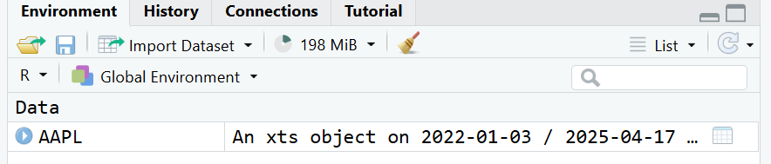

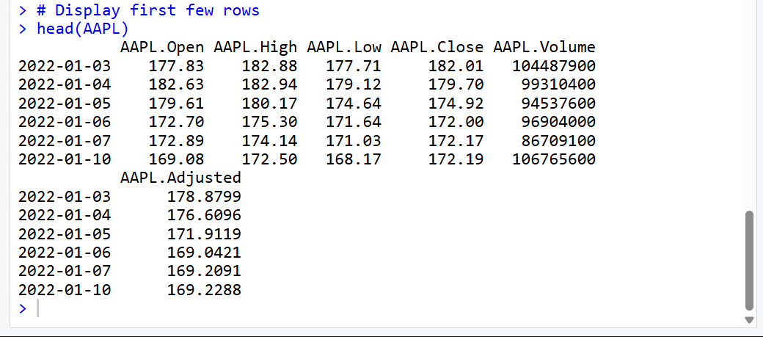

## **5. Calculate Moving Averages**

We calculate the 50-day and 200-day Simple Moving Averages (SMA) of the stock's closing prices. Moving averages help smooth out short-term fluctuations and highlight longer-term trends.

# Calculate 50-day Simple Moving Average

sma50 <- SMA(Cl(AAPL), n = 50)

# Calculate 200-day Simple Moving Average

sma200 <- SMA(Cl(AAPL), n = 200)

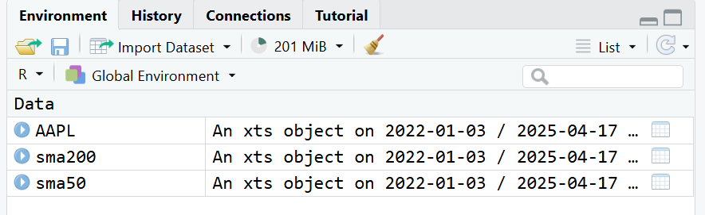

## **6. Visualize Stock Prices with Moving Averages**

We plot the Apple stock price along with its 50-day and 200-day SMAs to visually analyze trends.

# Plot the stock price chart with moving averages

chartSeries(AAPL, theme = chartTheme("white"), TA = NULL)

addSMA(n = 50, col = "blue")

addSMA(n = 200, col = "red")

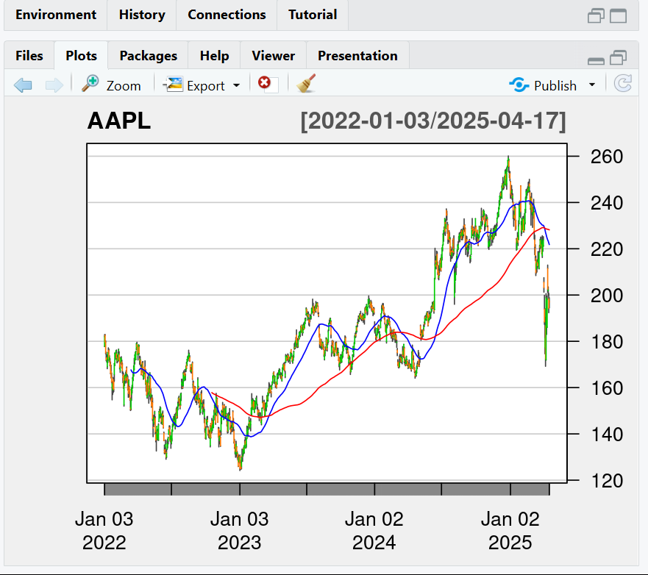

**Interpretation:**

* A crossover of the 50-day SMA above the 200-day SMA is often seen as a bullish signal.
* A crossover of the 50-day SMA below the 200-day SMA is considered a bearish signal.

## **7. Conclusion**

In this project, we successfully analyzed the stock prices of Apple Inc. by calculating and visualizing the 50-day and 200-day Simple Moving Averages (SMA). The analysis provided insights into the market trends, highlighting potential buy or sell signals based on SMA crossovers. Moving averages, particularly the 50-day and 200-day SMAs, are essential tools for smoothing out short-term price fluctuations and identifying long-term trends in the stock market.

Through this process, we learned how technical indicators can help investors make informed decisions by providing a clear picture of market movements. By visualizing the stock price alongside moving averages, we can interpret significant signals such as bullish or bearish trends, which can aid in determining optimal entry and exit points for investments.

This project also emphasizes the importance of using financial data analysis tools like quantmod in R, which provides an efficient way to access, analyze, and visualize stock market data. The ability to apply technical indicators such as moving averages to real-world financial data opens the door to further research and model development.